Experiment 7
Aim: Case Study on Hyperledger.
Blockchain Technology: Healthcare Record Sharing System using Hyperledger Fabric
1. Introduction
Modern healthcare systems rely heavily on Electronic Health Record (EHR) solutions to manage patient medical histories, diagnostic tests, treatment plans, and clinical observations. However, legacy EHR deployments operate in isolated data silos managed independently by individual hospitals, clinics, and diagnostic laboratories. This fragmented architecture leads to severe interoperability bottlenecks, preventing seamless data exchange across organizational boundaries.
When a patient transitions between different care providers, critical medical records are often unavailable, leading to redundant diagnostic procedures, delayed medical interventions, and elevated operational costs. Furthermore, centralized EHR databases represent high-value targets for cyberattacks, single points of failure, and unauthorized data monetization. Ensuring data integrity, supporting patient privacy regulations, and fine-grained access governance across cross-organizational healthcare networks requires a paradigm shift toward decentralized, tamper-proof infrastructure.
Blockchain technology offers a promising decentralized framework for establishing multi-party trust, immutability, and auditable data sharing without relying on a centralized intermediary. This case study explores the architectural design and working principle of a permissioned blockchain solution using Hyperledger Fabric to solve the cross-organizational healthcare record sharing challenge.
2. Private / Permissioned Blockchain
Blockchain networks broadly fall into two main operational categories: Public (Permissionless) and Private/Permissioned. Public blockchains (such as Bitcoin or Ethereum) allow any anonymous node to join the network, participate in consensus, read ledger state, and issue transactions. While public blockchains achieve high decentralization, their transparent nature and computationally expensive consensus mechanisms (Proof-of-Work / Proof-of-Stake) render them unsuitable for sensitive healthcare applications.
In contrast, a Permissioned Blockchain operates under a consortium model where network participants are known, cryptographically identified, and explicitly authorized by a governance framework. In a permissioned healthcare consortium, participating entities—such as Hospital A, Hospital B, and Diagnostic Laboratories—maintain peer nodes. The network enforces strict role-based access control, predictable transaction processing and finality within the configured permissioned network, and zero exposure of confidential data to the public Internet.
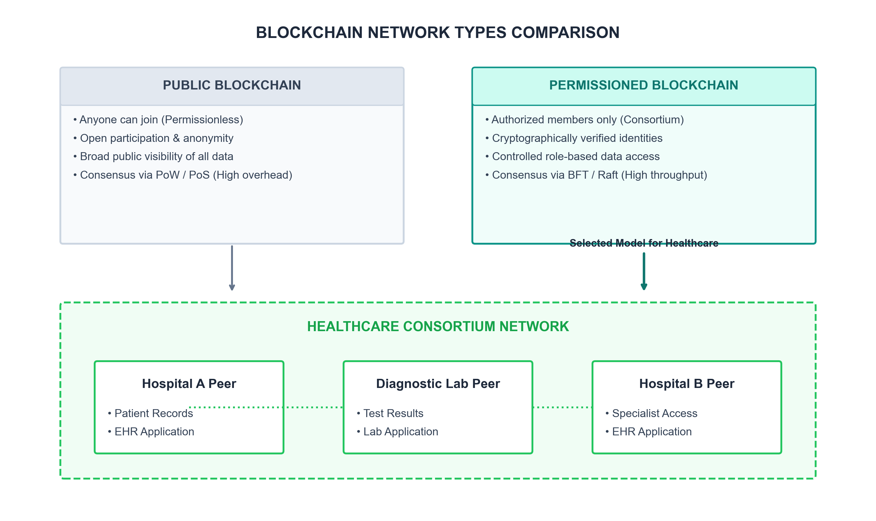
Figure 1: Permissioned blockchain model for a healthcare consortium.
3. Hyperledger Fabric Framework & Components
3.1 Overview of Hyperledger Fabric
Hyperledger Fabric is an open-source, enterprise-grade permissioned blockchain framework hosted by the Linux Foundation. Unlike general-purpose public blockchains, Fabric features a modular, pluggable architecture designed specifically for enterprise deployment. Key architectural differentiators include fine-grained channel isolation, pluggable consensus algorithms (such as Raft), executing chaincode (smart contracts) in general-purpose languages (Go, Java, Node.js), and support for private data collections.
3.2 Main Components Used in the Case Study
The proposed healthcare record sharing case study leverages several core Hyperledger Fabric architectural components:
• Peer Nodes: Network nodes hosted by Hospital A, Hospital B, and Diagnostic Laboratories. Peers maintain a copy of the ledger and execute smart contract code. Endorsing Peers execute transactions and cryptographically sign proposal responses.
• Channels: Isolated communication sub-networks established between specific consortium members. Channels enable private transactions and ensure that ledger data is visible only to authorized channel members.
• Chaincode (Smart Contract): Decentralized business logic deployed on peers that governs state updates, patient consent validation, asset registration, and record access controls.
• World State Database: A key-value state database (e.g., CouchDB) that stores the current state of ledger assets, enabling fast, complex rich queries on patient record metadata.
• Ordering Service (Orderer): A Raft-based consensus cluster that receives endorsed transactions, orders them chronologically into blocks, and broadcasts blocks to channel peers for validation and commitment.
• Certificate Authority (Fabric-CA) & MSP: Membership Service Providers (MSP) use Fabric-CA to issue X.509 digital certificates, verifying the cryptographic identities of doctors, patients, lab technicians, and nodes.
• Private Data Collections (PDC): Enables sensitive metadata sharing strictly between a subset of authorized peers without broadcasting data across the entire channel.
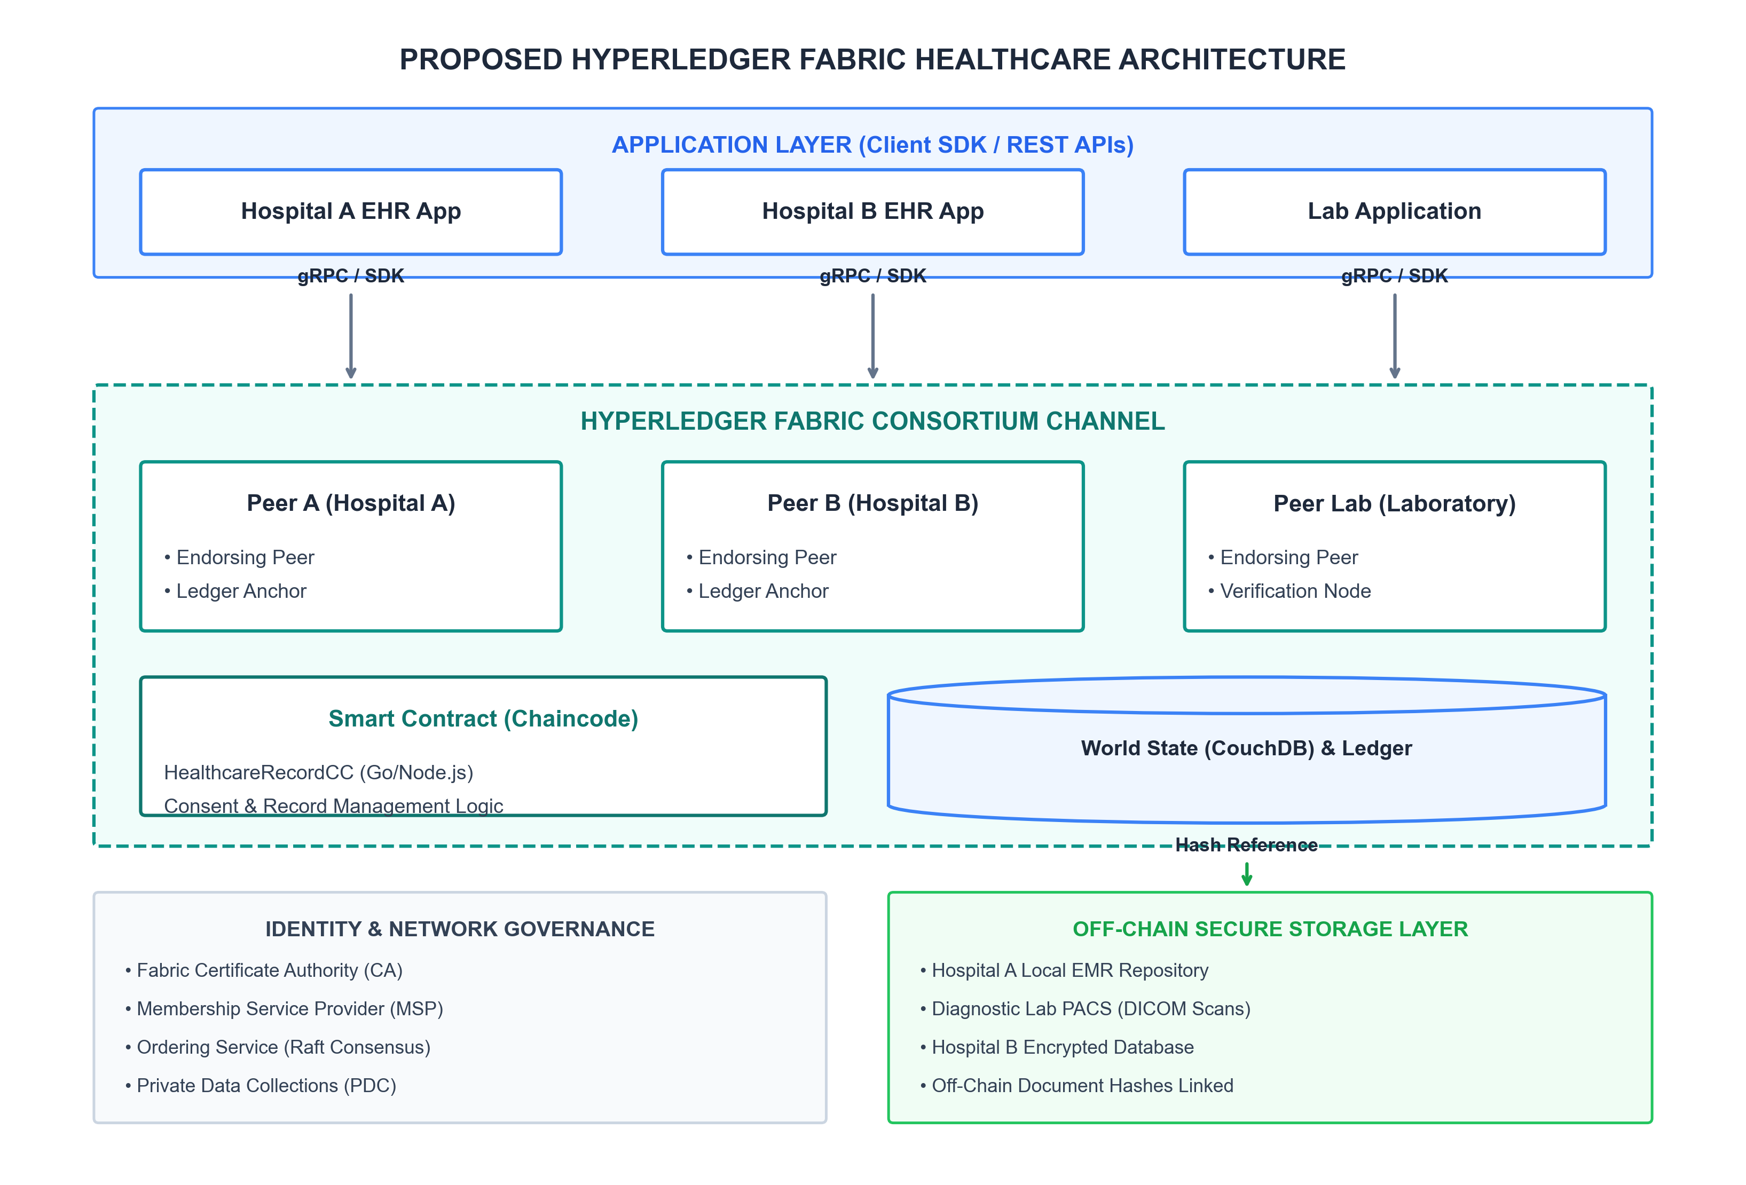
Figure 2: Proposed Hyperledger Fabric architecture for secure healthcare record sharing.
4. Healthcare Case Study: Problem Statement & Objectives
4.1 Problem Statement
Healthcare providers face four primary systemic challenges in legacy record management:
1. Data Fragmentation & Silos: Patient records are distributed across incompatible hospital databases without unified indexing.
2. Lack of Immutable Auditability: Centralized databases can be altered, overwritten, or deleted by unauthorized administrators without leaving a tamper-evident audit trail.
3. Vulnerability to Data Breaches: Concentrated EMR storage is vulnerable to ransomware and unauthorized data exfiltration.
4. Absence of Patient-Centric Consent: Patients have minimal control or visibility over which organizations access, share, or transfer their confidential health data.
4.2 System Design Objectives
The proposed Hyperledger Fabric solution aims to achieve the following core objectives:
• Establish an immutable, tamper-proof audit trail of all record creation, modification, and access events.
• Enforce fine-grained, patient-driven consent management embedded directly within chaincode logic.
• Support healthcare privacy and regulatory requirements through strict separation of on-chain metadata and off-chain confidential storage.
• Deliver predictable transaction processing and finality across consortium members.
5. Data Visibility, Privacy & Asset Modeling
5.1 Data Visibility and Privacy
Storing complete medical records directly on a replicated blockchain can create significant privacy, data-governance and regulatory challenges, particularly where regulations require modification, deletion or strict control over personal data.
To resolve this, the system enforces a hybrid data model: full confidential medical documents remain stored in secure off-chain hospital EMR repositories or encrypted cloud storage. Only cryptographic document hashes (SHA-256 digests), record metadata, URI references, and consent rules are committed on-chain to the Fabric ledger.
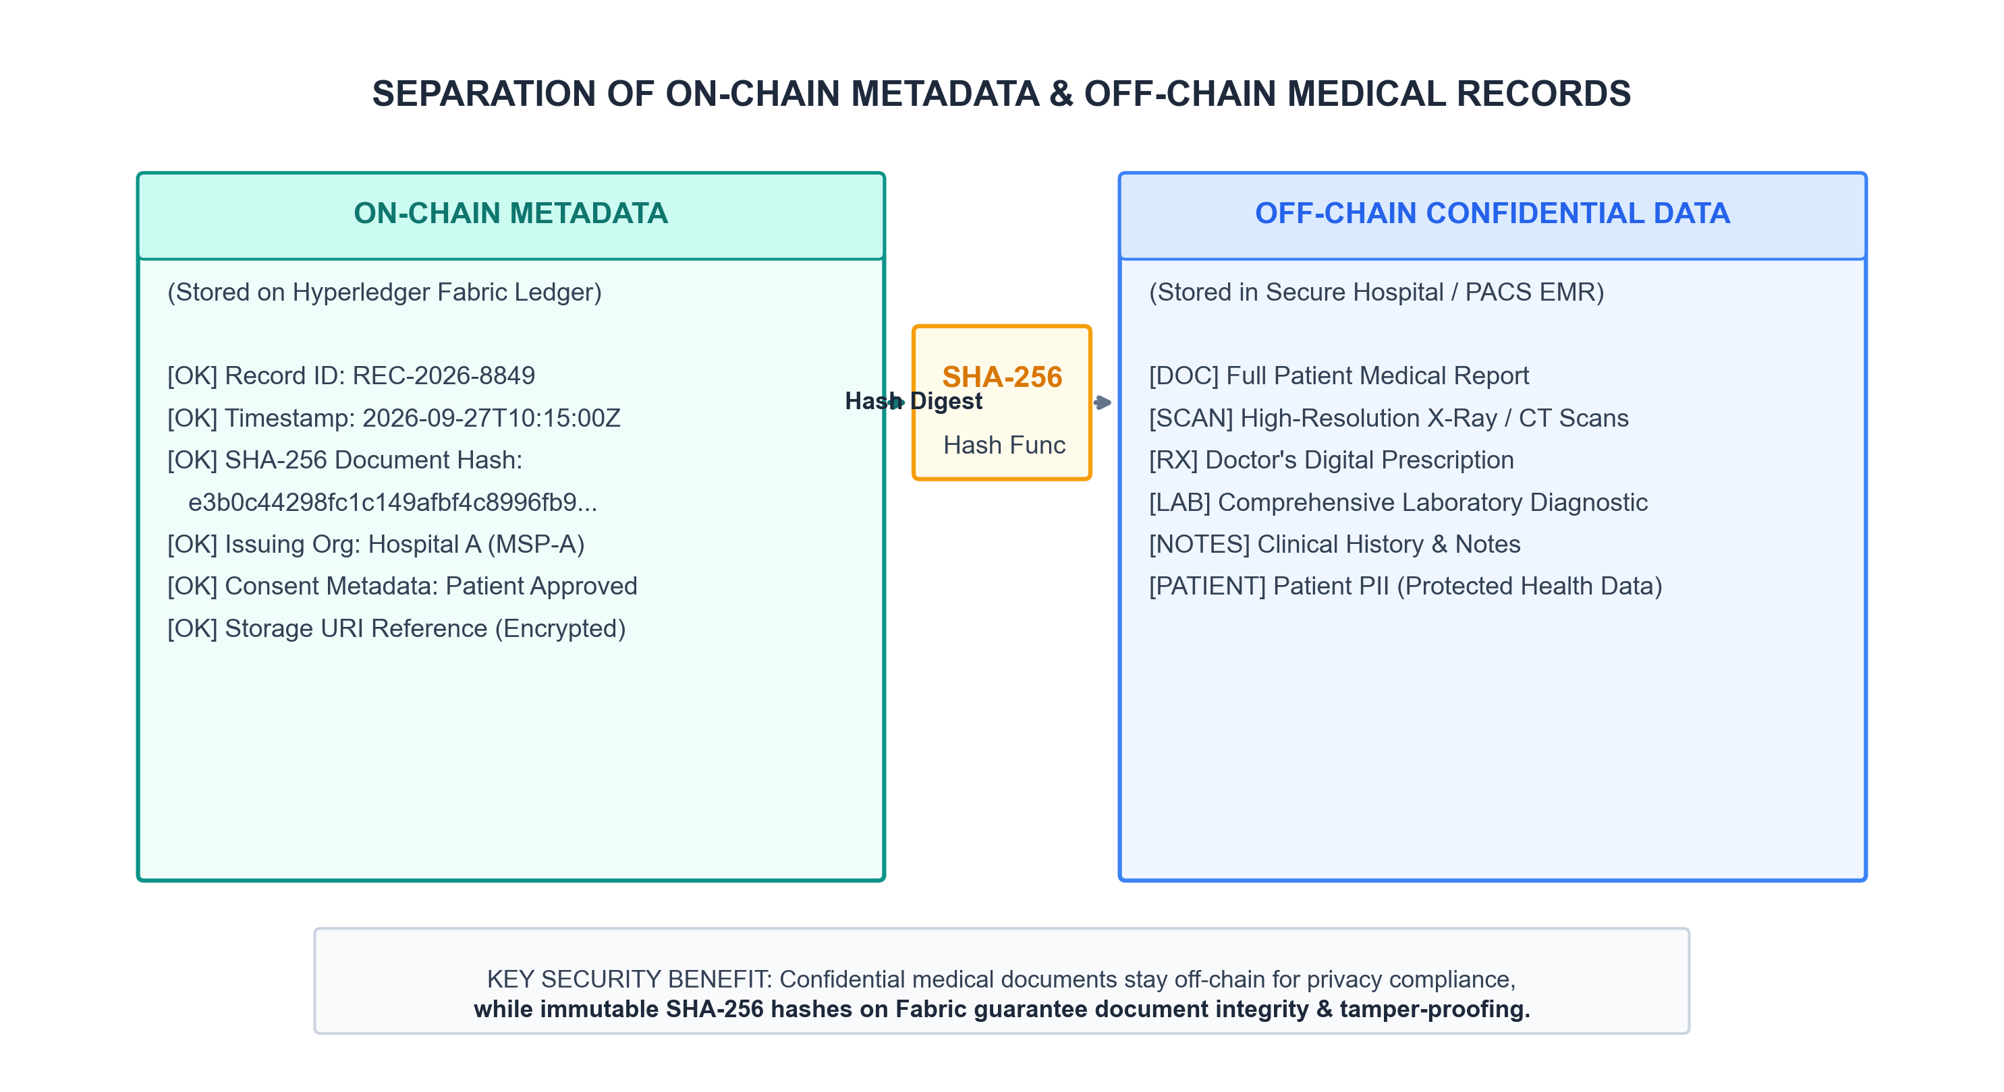
Figure 3: Separation of blockchain metadata from confidential off-chain healthcare records.
5.2 Logical Asset Model
The core ledger asset is modeled as a PatientRecordReference object within the Go chaincode. This structure encapsulates cryptographic proofs and access metadata while omitting readable protected health information (PHI).
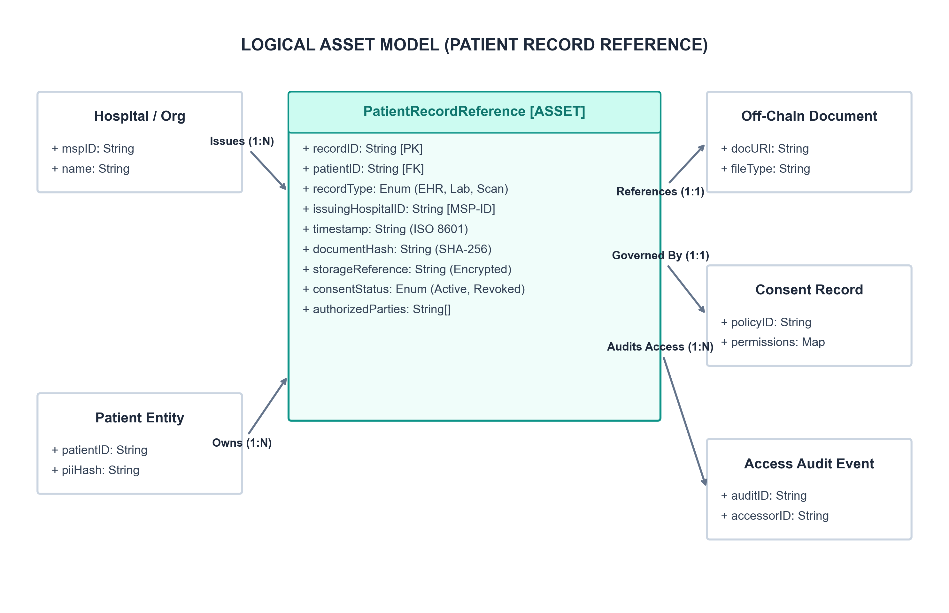
Figure 4: Logical asset model for a healthcare record reference.
6. Working Principle & Transaction Workflow
Hyperledger Fabric executes transactions using a novel Execute-Order-Validate paradigm, separating transaction execution and endorsement from ordering and state commitment. This prevents non-deterministic execution and enables parallel processing.
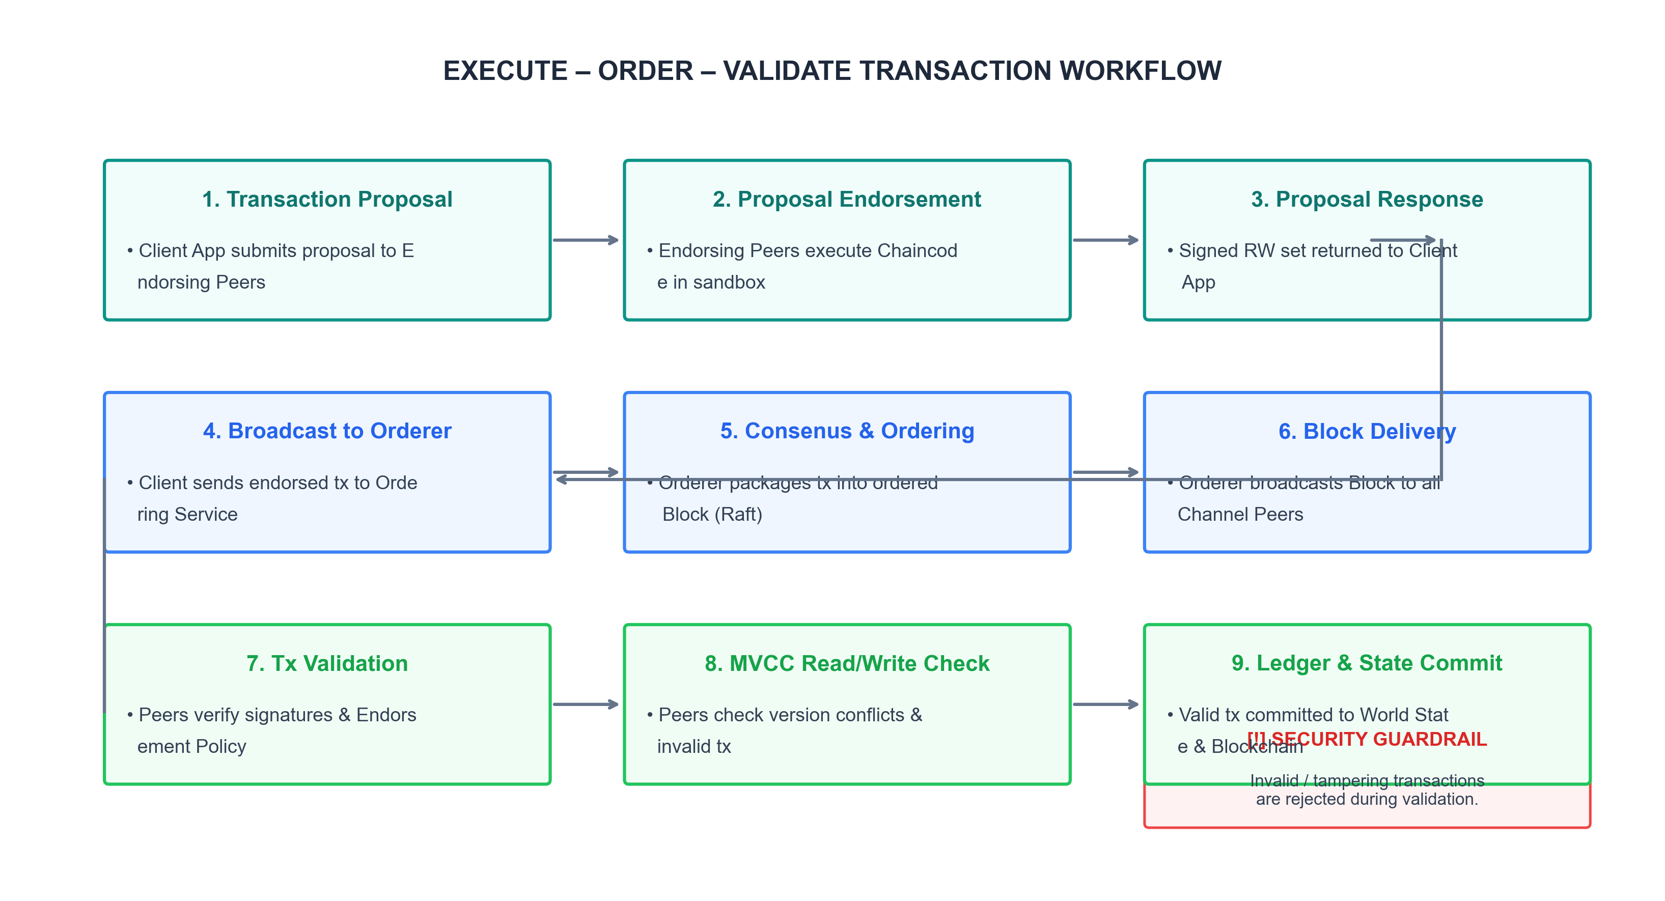
Figure 5: Execute–Order–Validate transaction workflow for the proposed healthcare network.
6.1 Patient Record Life-Cycle
A patient's healthcare record progresses through seven distinct lifecycle stages, each generating an immutable, auditable event recorded on the Fabric ledger:
1. Registration: Patient registers identity with Fabric-CA and receives cryptographic credentials.
2. Consultation: Primary care physician creates initial medical observation record.
3. Diagnostic Testing: Laboratory technician generates diagnostic test report and registers SHA-256 hash on-chain.
4. Treatment & Prescription: Doctor issues digital prescription linked to the patient's record hash.
5. Specialist Referral: Patient delegates access permission to a specialist at Hospital B.
6. Cross-Hospital Follow-up: Hospital B specialist queries and retrieves document after chaincode consent validation.
7. Record Verification: Periodic automated integrity audits verify that off-chain files match ledger SHA-256 hashes.
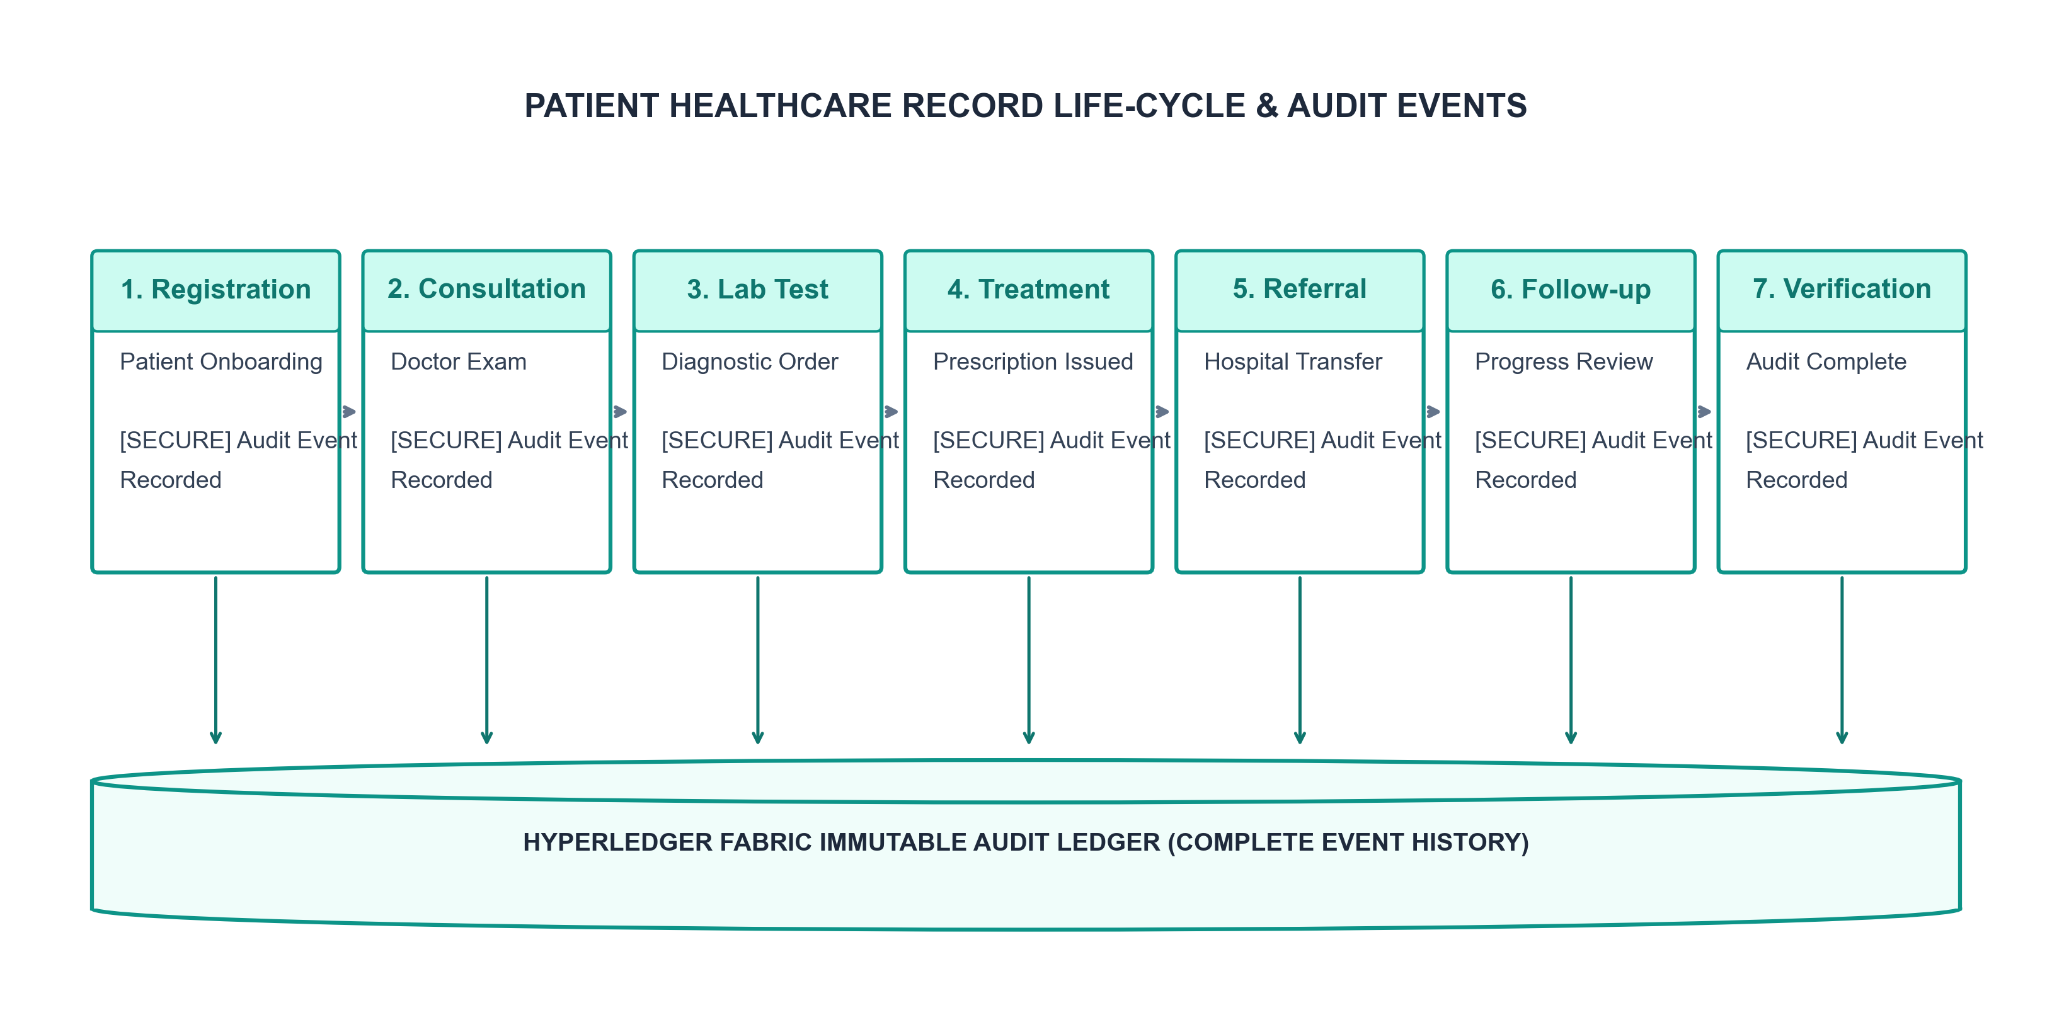
Figure 6: Patient healthcare-record life-cycle and corresponding audit events.
6.2 Example End-to-End Scenario
Consider a practical scenario involving a patient transferred from Hospital A to Hospital B for specialized cardiology care:
• Step 1–3: A cardiologist at Hospital A orders an ECG and blood panel. The diagnostic lab generates the report, uploads the raw file to secure off-chain storage, and invokes the Fabric chaincode to register `REC-2026-8849` with its SHA-256 hash digest.
• Step 4–6: The patient logs into the mobile consent portal and grants read access to Hospital B's Cardiology Department MSP for 7 days.
• Step 7–10: Hospital B's EHR application submits a record request to Peer B. Peer B executes chaincode, verifies active consent, fetches the off-chain document from Hospital A's repository, compares the computed SHA-256 hash against the ledger state, and commits an immutable Access Log Event.
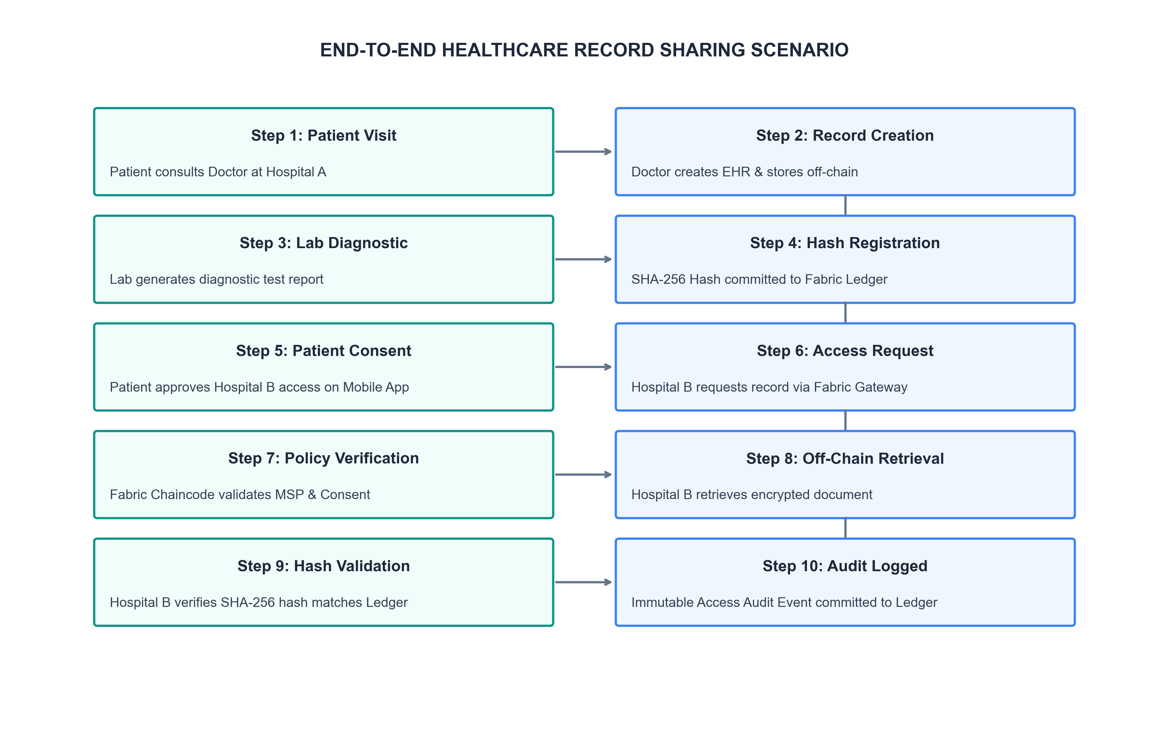
Figure 7: End-to-end healthcare record-sharing scenario using Hyperledger Fabric.
7. Chaincode (Smart Contract) Implementation Details
The smart contract logic is implemented in Go (`HealthcareRecordCC`). Key smart contract functions include:
• `CreateRecordReference(ctx, recordID, patientID, docHash, storageURI)`: Validates issuing organization MSP identity, constructs `PatientRecordReference`, and commits asset to World State.
• `GrantConsent(ctx, patientID, targetOrgMSP, duration)`: Updates the patient's consent control mapping in World State, setting access expiration timestamps.
• `RevokeConsent(ctx, patientID, targetOrgMSP)`: Immediately revokes target organization access privileges.
• `VerifyAndRetrieveRecord(ctx, recordID, accessorMSP)`: Evaluates calling identity against consent permissions. If authorized, returns storage URI and reference hash, while appending an immutable audit trail entry.
8. Data Privacy and Access Control Model
Access control is governed through a multi-layered security framework combining Attribute-Based Access Control (ABAC) and Role-Based Access Control (RBAC) enforced at the Fabric SDK and chaincode layers. Access requests are authorized only when the accessor possesses a valid X.509 certificate issued by an approved MSP and an active patient consent grant.
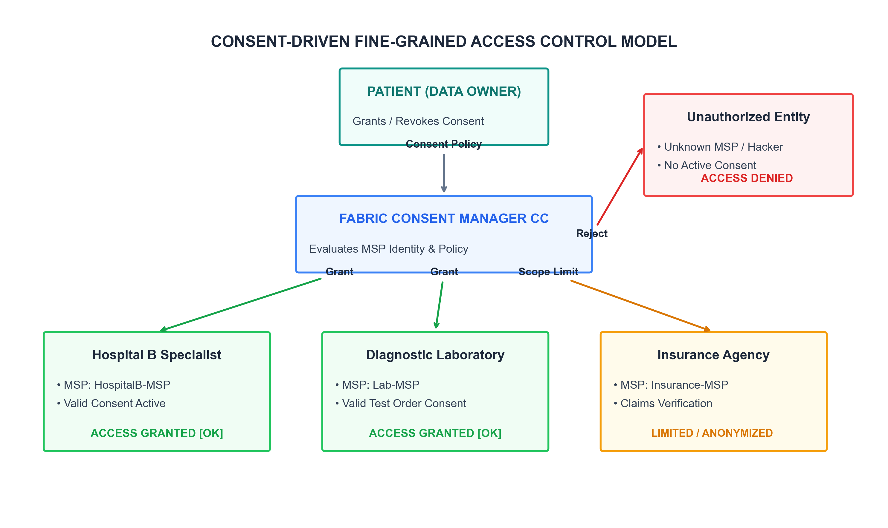
Figure 8: Consent-driven access control for healthcare records.
9. Results, Performance & Security Analysis
The proposed architecture is evaluated conceptually based on privacy, access control, auditability, transaction processing and organizational governance. Since the system is a proposed case-study design and has not been deployed as a production healthcare network, numerical performance values are not claimed.
Evaluation Metric | Conventional EHR | Public Blockchain | Proposed Fabric Consortium
Data Privacy | Organization-controlled | Broad ledger visibility | Permissioned and controlled
Identity | Application authentication | Often pseudonymous | Certificate-based identity
Access Control | Database/application rules | Limited application-level control | Chaincode + organizational policies
Auditability | Organization-specific logs | Public transaction history | Permissioned shared audit trail
Confidential Data | Centralized storage | Difficult to restrict | Off-chain + private data
Governance | Single organization | Open network governance | Consortium governance

10. Limitations & Future Enhancements
While the proposed system addresses core healthcare record sharing challenges, certain technical limitations exist:
• Key Management Complexity: Patients must securely store private cryptographic keys for consent signing. Key recovery mechanisms must be developed for non-technical users.
• Off-Chain Storage Availability: If an issuing hospital's off-chain EMR server experiences downtime, document retrieval is delayed despite valid ledger hash verification.
• Future Enhancements: Integration of Zero-Knowledge Proofs (ZKP) to enable verifiable clinical queries (e.g., proving a patient is vaccinated) without revealing raw medical attributes.
11. Key Technical Learnings & Practical Takeaways
Key insights gained from designing this permissioned healthcare blockchain case study:
1. Permissioned Architecture Choice: Hyperledger Fabric's MSP and channel architecture align perfectly with enterprise privacy and regulatory governance needs.
2. Hybrid Data Storage Design: Never store raw sensitive medical data on-chain; combine off-chain storage with on-chain cryptographic hashes to achieve both immutability and compliance support.
3. Execute-Order-Validate Efficiency: Decoupling endorsement execution from ordering consensus yields predictable processing suitable for multi-hospital networks.
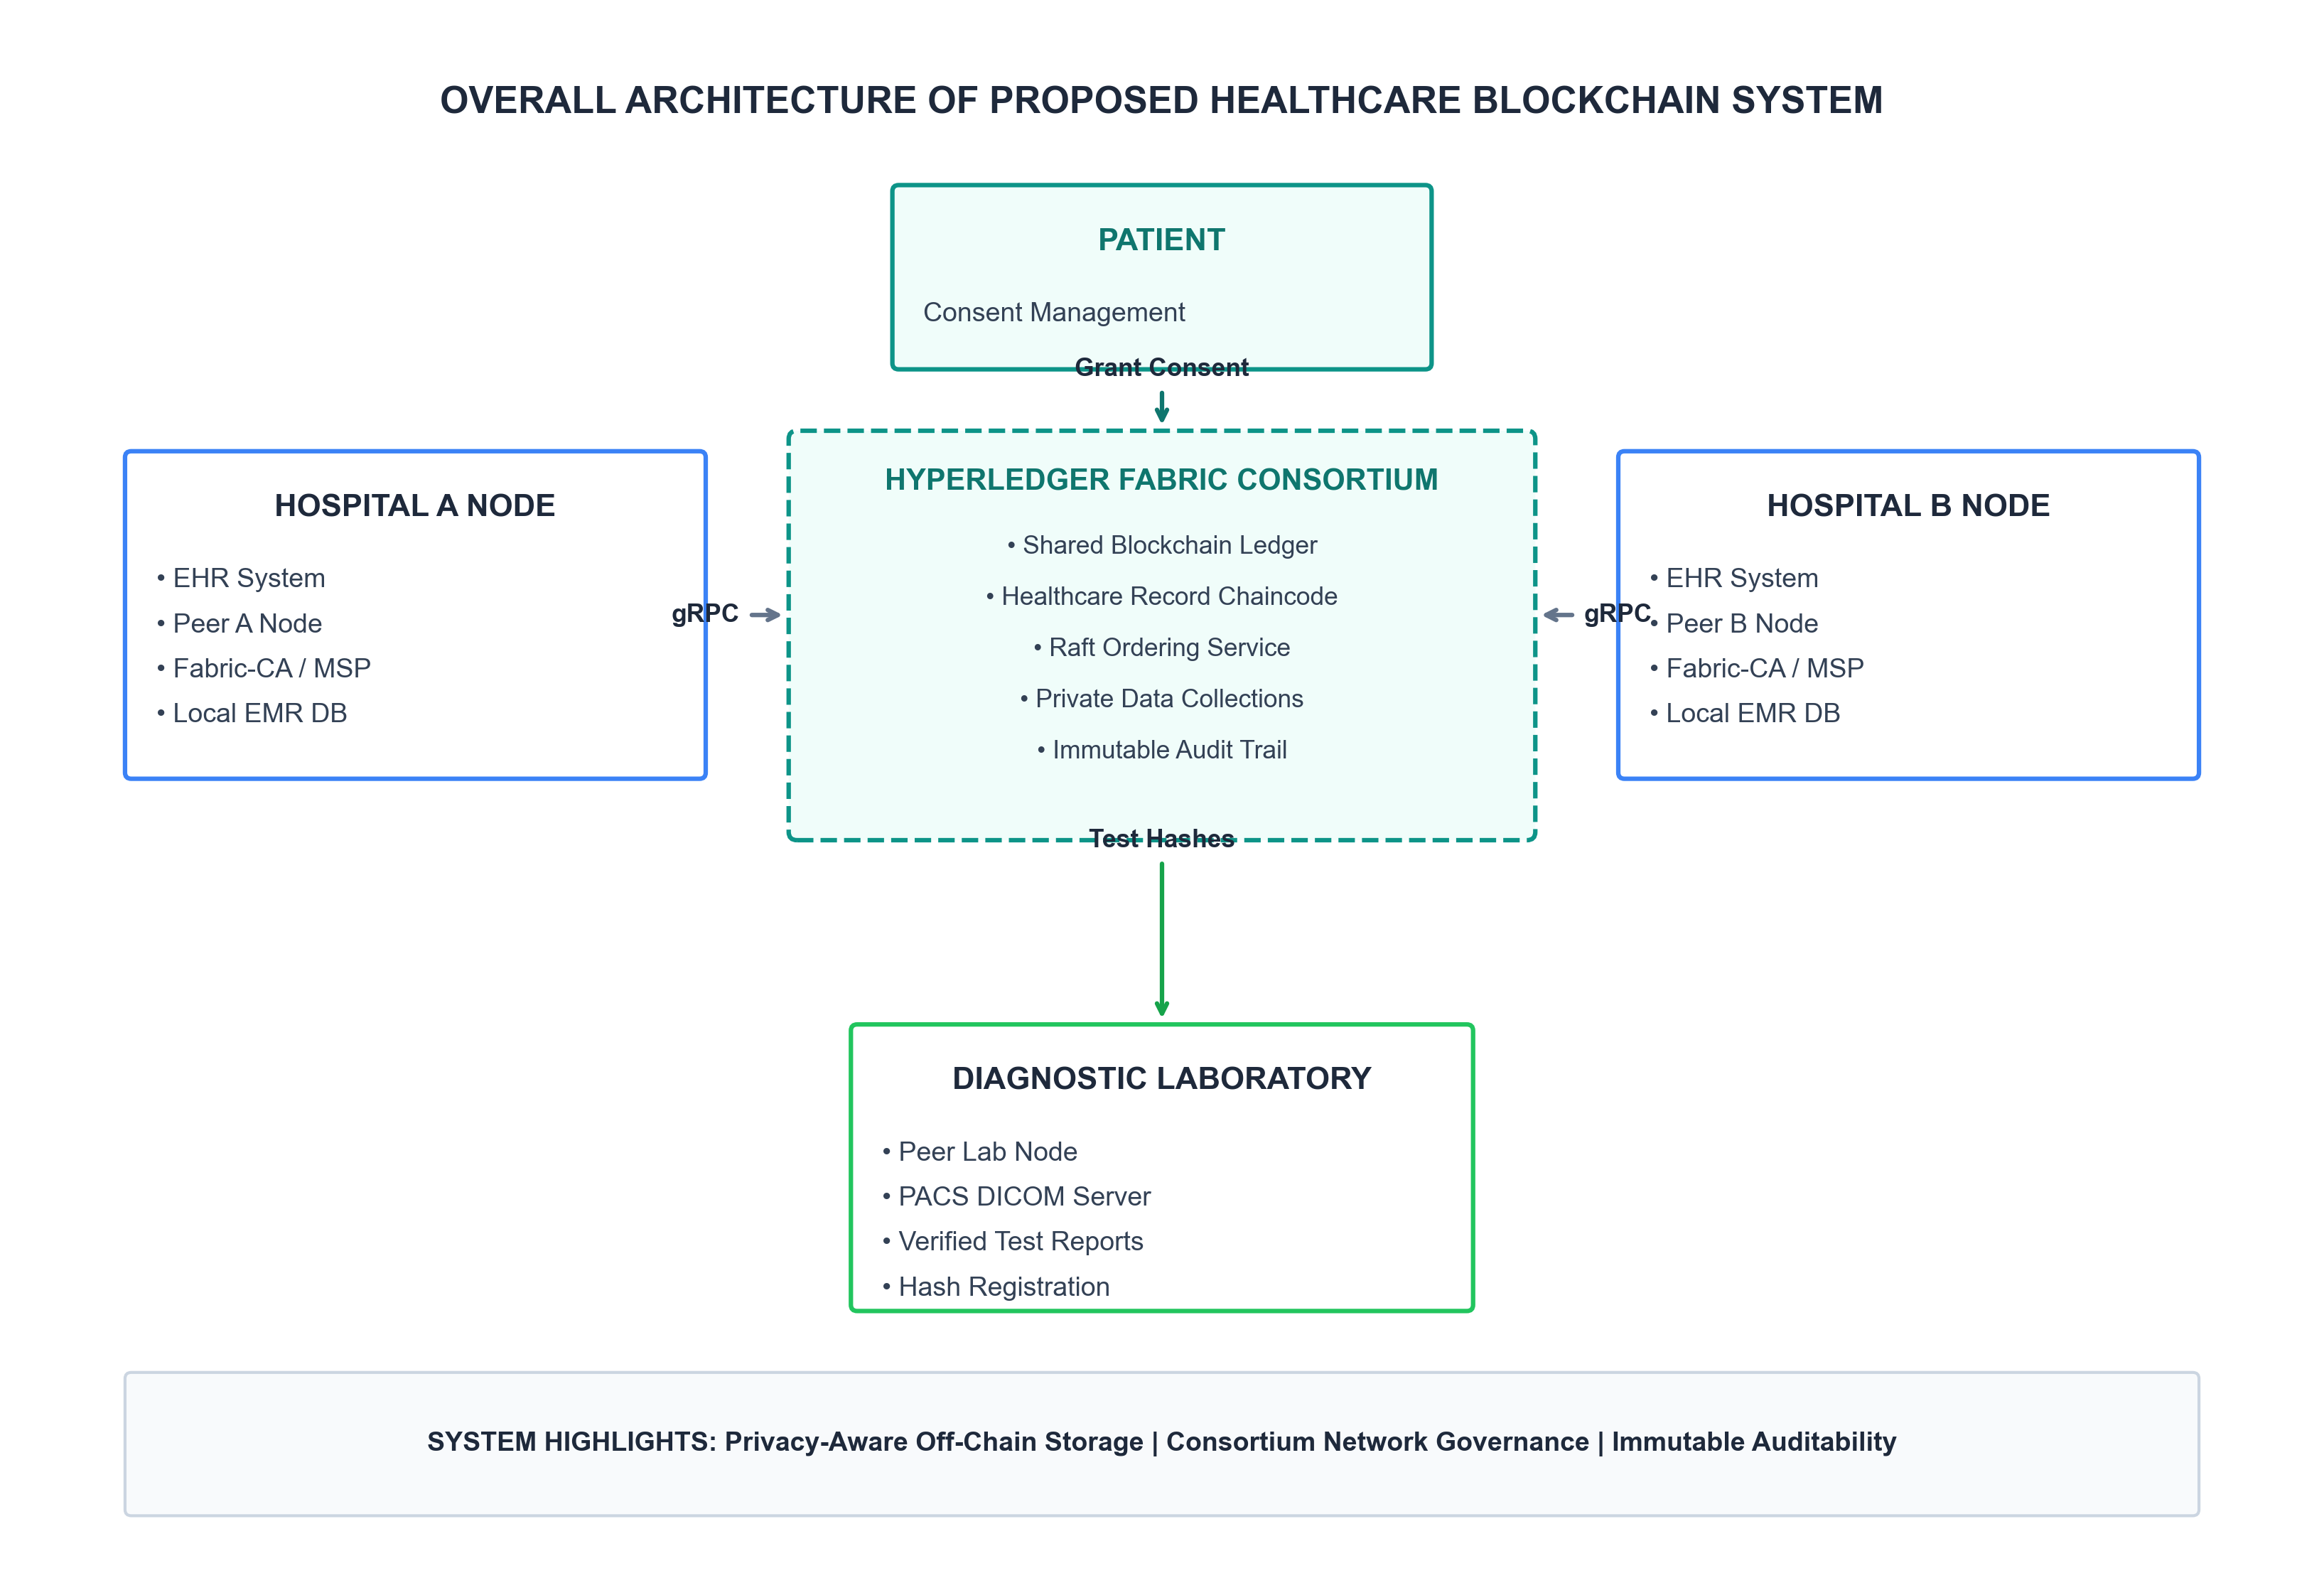
Figure 9: Overall architecture of the proposed blockchain-based healthcare record-sharing system.
12. Conclusion
This technical case study demonstrated the design and working principle of a permissioned blockchain solution for secure healthcare record sharing using Hyperledger Fabric. By combining cryptographically verified consortium identities, fine-grained chaincode consent management, Execute-Order-Validate transaction workflows, and hybrid on-chain/off-chain storage, the proposed system solves the legacy challenges of data silos, single points of failure, and unauthorized data access. The resulting architecture provides a potential blueprint for privacy-aware healthcare interoperability, subject to applicable legal, regulatory, security and organizational requirements.
References
1. Hyperledger Fabric Documentation. 'Hyperledger Fabric Architecture and Components.' Linux Foundation, 2024. https://hyperledger-fabric.readthedocs.io/
2. Androulaki, E., et al. 'Hyperledger Fabric: A Distributed Operating System for Permissioned Blockchains.' Proceedings of the 13th EuroSys Conference, 2018.
3. Azaria, A., Ekblaw, A., Vieira, T., & Lippman, A. 'MedRec: Using Blockchain for Medical Data Access and Permission Management.' IEEE International Conference on Open and Big Data, 2016.
4. U.S. Department of Health & Human Services. 'Health Insurance Portability and Accountability Act (HIPAA) Privacy and Security Rules.' 2023.

